

DEEP LEARNING ALGORITHMS AND APPLICATIONS [CSE767]

REPORT FILE
Develop Application based on LSTM

SUBMITTED TO:
Prof.(Dr) Sarika Jain

SUBMITTED BY:
Saloni. R. Ganvir
Enrolment Number: A010175625017

INTRODUCTION
In recent years, Artificial Intelligence has significantly improved user experience in text-based applications. One such feature is auto-complete, which predicts the next word based on previous input. This project focuses on building a Smart Typing Autocomplete System using Long Short-Term Memory (LSTM), a type of Recurrent Neural Network (RNN).
The main objective of this project is to design a model that can understand the sequence of words and predict the next word accurately. This helps in improving typing speed, reducing effort, and enhancing user interaction.
The model was developed using Python and implemented on Google Colab, making it easy to train and test without heavy system requirements.

OBJECTIVE OF THE PROJECT
The primary objectives of this project are:
- To understand and implement LSTM for sequence prediction
- To build a next-word prediction system
- To preprocess and convert text data into numerical format
- To train a deep learning model and evaluate its performance
- To simulate real-world autocomplete functionality

METHODOLOGY
The project follows a structured approach:
🔸 Data Collection
A custom dataset was created in CSV format containing around 300 sentences related to AI, learning, and technology. The dataset was designed to be balanced and lightweight, making it suitable for training in limited computational environments.
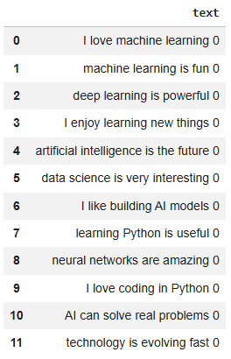
🔸Data Preprocessing
The text data was cleaned by:
- Converting all text to lowercase
- Removing special characters and numbers
This step ensures that the model learns only meaningful patterns.
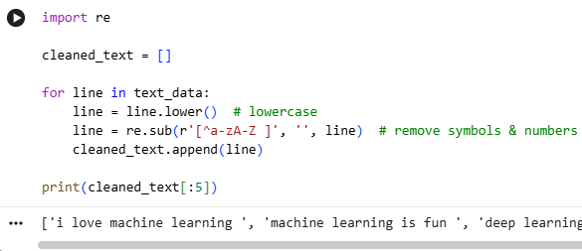
🔸Tokenization
Tokenization was performed to convert words into numerical form using Keras Tokenizer. This step is essential because neural networks cannot process raw text.
Example:
"I love AI" → [1, 2, 3]
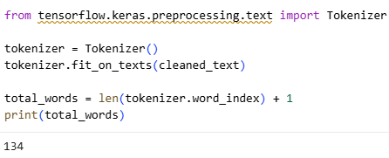
🔸Sequence Generation
Sequences were created to train the model for next-word prediction.
Example:
"I love machine learning"
→ [I, love]
→ [I, love, machine]
→ [I, love, machine, learning]
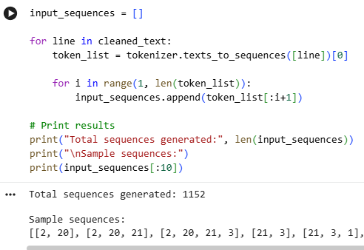
🔸Padding
All sequences were padded to the same length to ensure uniform input size for the model.
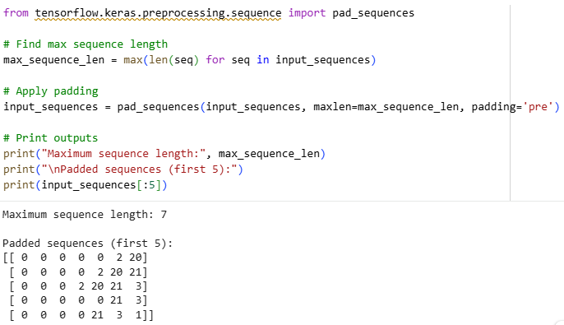
🔸Model Building
A Sequential deep learning model was built consisting of:
- Embedding Layer → Converts words into vectors
- LSTM Layer → Learns sequence patterns
- Dense Layer → Predicts next word
The model was compiled using:
- Loss: Categorical Crossentropy
- Optimizer: Adam
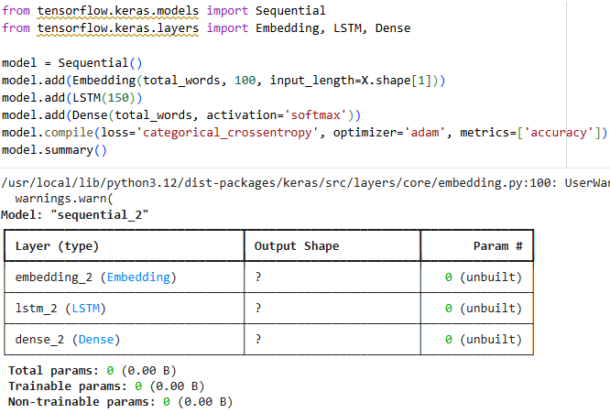
🔸Training
The model was trained for 50 epochs, allowing it to learn patterns effectively. During training, accuracy improved gradually.
Final accuracy achieved: ~85%
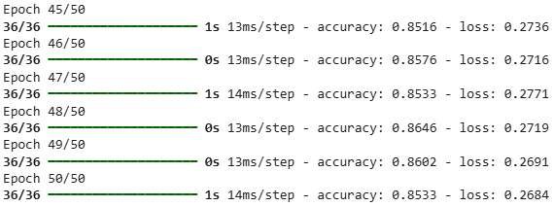
🔸Prediction
A prediction function was implemented to take user input and predict the next word.
Example:
Input: "machine learning"
Output: "is"
1)
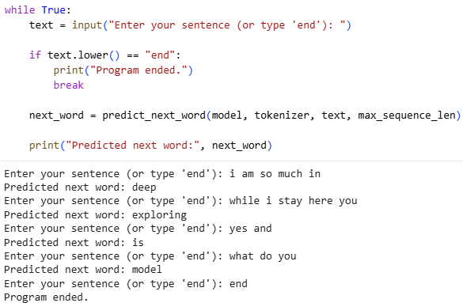
2)
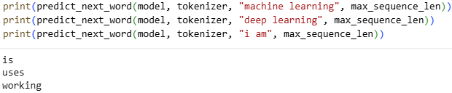

WORKING of LSTM and GATES
The LSTM layer is the core of this model and works using four gates:
🔸 Forget Gate
Removes irrelevant information from previous context.
🔸 Input Gate
Decides what new information to store.
🔸 Cell State
Acts as memory and carries important information forward.
🔸 Output Gate
Generates the final output based on learned patterns.
These gates help the model overcome the limitations of traditional RNNs by maintaining long-term dependencies.

RESULTS & OBSERVATIONS
- The model successfully predicts context-based next words
- Accuracy achieved was approximately 85%
- Predictions were logical and aligned with training data
- Performance improves with better dataset quality
Example outputs:
machine learning → is
deep learning → uses
i am → learning

APPLICATIONS
- Mobile keyboard auto-complete
- Chatbots
- Text generation systems
- Email suggestion systems
- AI writing assistants

CONCLUSION
This project demonstrates the effectiveness of LSTM in handling sequential data and predicting future elements based on past input. By implementing tokenization, sequence generation, and deep learning techniques, a functional autocomplete system was successfully developed.
The project highlights how deep learning can be applied to real-world problems and serves as a strong foundation for more advanced NLP applications.

FUTURE SCOPE
- Improve dataset size for better accuracy
- Add multi-word prediction
- Build a web interface using Streamlit
- Deploy model as a real-time application

Note: .pynb file-

